WELCOME TO HTML & CSS CLASS

**What is HTML?**

HTML is a Markup Language used in building or developing the structure of an App [either Web or Mobile App]. Full meaning of HTML

* Hyper Text means that it uses the HTTP part of the internet
* Markup means the written code is annotated with keywords
* Language means it can be read by both human and computer

HTML isn’t a programming language and you cannot use it to program set of computer algorithm [i.e. to tell computer what to do], rather it is a Markup Language used to define building blocks or basics of an applications.

Think of the process of the constructing a building, the first step is to laid the foundation of the building, then followed by the main structure of the building. [ see the [picture below for reference]. Usage of HTML represents such a process in building an application.

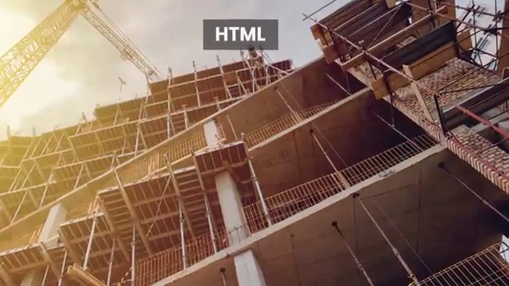

Any HTML page is usually written or coded in a in tree-like structure called **DOM** [Documents Object Model].